

Student Name……………………………………

MATHEMATICAL METHODS (CAS) UNITS 3 & 4

TRIAL EXAMINATION 1

2013

Reading Time: 15 minutes
Writing time: 1 hour

Instructions to students
This exam consists of 10 questions.
All questions should be answered in the spaces provided.
There is a total of 40 marks available.
The marks allocated to each of the questions are indicated throughout.
Students may not bring any calculators or notes into the exam.
If a question requires a numerical answer then an exact value must be given unless a decimal approximation is specifically asked for.
Where more than one mark is allocated to a question, appropriate working must be shown.
Diagrams in this trial exam are not drawn to scale.
A formula sheet can be found on page 11 of this exam.

This paper has been prepared independently of the Victorian Curriculum and Assessment Authority to provide additional exam preparation for students. Although references have been reproduced with permission of the Victorian Curriculum and Assessment Authority, the publication is in no way connected with or endorsed by the Victorian Curriculum and Assessment Authority.

© THE HEFFERNAN GROUP 2013
This Trial Exam is licensed on a non transferable basis to the purchasing school. It may be copied by the school which has purchased it. This license does not permit distribution or copying of this Trial Exam by any other party.
Question 1 (3 marks)

- Differentiate 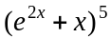 with respect to x.
(1 mark)

- Let 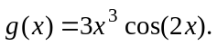 Evaluate 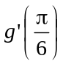.
(2 marks)

Question 2 (2 marks)

Find 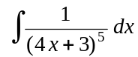.

Question 3 (4 marks)

Let 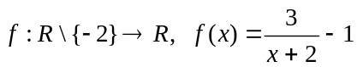.

- Find 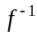, the inverse function of f.
(3 marks)

- Let 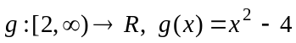.

Find the rule for 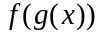.
(1 mark)

Question 4 (5 marks)

The random variable X is normally distributed with mean 142 and variance 16. The random variable Z is the standard normal variable.

- If 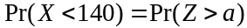, find the value of a.
(2 marks)

- Using the result that 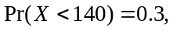 correct to 1 decimal place, find

i. 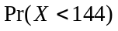. (1 mark)

______________________________________________________________

______________________________________________________________

______________________________________________________________

______________________________________________________________

ii. 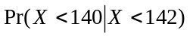. (2 marks)

______________________________________________________________

______________________________________________________________

______________________________________________________________

______________________________________________________________

______________________________________________________________

______________________________________________________________

______________________________________________________________

Question 5 (4 marks)

Let 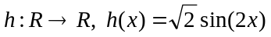.

- Find the range of h.
(1 mark)

- Solve the equation 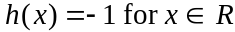.
(3 marks)

Question 6 (3 marks)

The random variable X has a probability density function given by

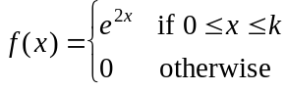

Find the value of k, expressing your answer in the form 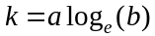 where a and b are positive constants.

___________________________________________________________________________

___________________________________________________________________________

___________________________________________________________________________

___________________________________________________________________________

___________________________________________________________________________

___________________________________________________________________________

___________________________________________________________________________

___________________________________________________________________________

___________________________________________________________________________

___________________________________________________________________________
Question 7 (4 marks)

For the simultaneous linear equations

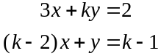

k is a real constant.

- Find the value of k for which there are no solutions.
(3 marks)

- For what values of k does a unique solution exist?
(1 mark)

Question 8 (4 marks)

Let 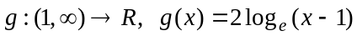.
The graph of g is shown below.
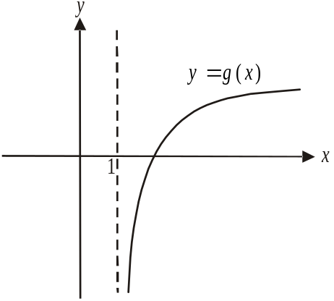

- Find the x-coordinate of the point of intersection between the graph of g and the line with equation 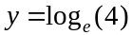.
(2 marks)

- i. Find the derivative function 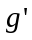.
(1 mark)

- Hence explain why the gradient of the graph of g is always positive.
(1 mark)

Question 9 (4 marks)

Let .

Find the area enclosed by the graphs of f and h and the line with equation .

Question 10 (7 marks)

Let 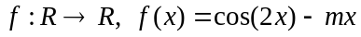 where m is a real constant.

- i. Find 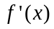 in terms of m.
(1 mark)

- Find the value of m if a stationary point on the graph of 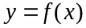 occurs at the point where 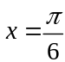.
(2 marks)

- Find the equation of the tangent to the graph of f at the point where 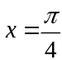.
(3 marks)

- If the tangent found in part b., passes through the point 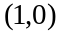, find the value of m.
(1 mark)

Mathematical Methods (CAS) Formulas

Mensuration

area of a trapezium: 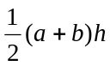 volume of a pyramid: 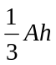
curved surface area of a cylinder: 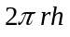 volume of a sphere: 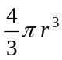
volume of a cylinder: 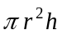 area of a triangle: 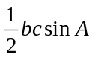
volume of a cone: 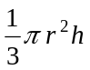

Calculus
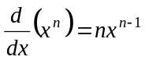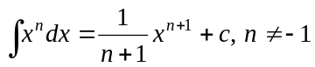
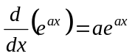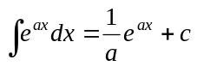
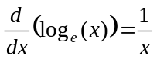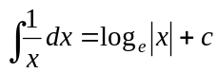
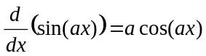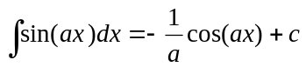
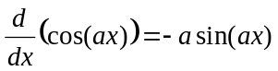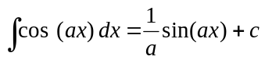
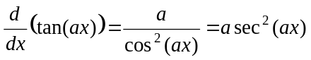
product rule: 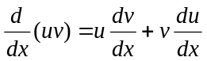 quotient rule: 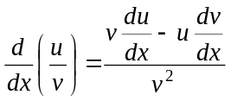
chain rule: 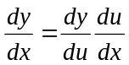 approximation: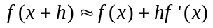

Probability
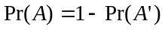
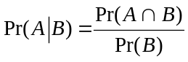 transition matrices: 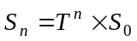
mean: 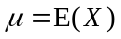 variance:

probability distribution |  | mean | variance
discrete | 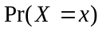=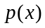 | 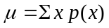 | 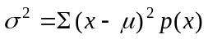
continuous | 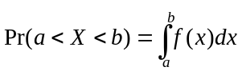 | 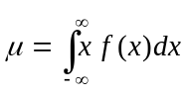 | 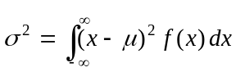
Reproduced with permission of the Victorian Curriculum and Assessment Authority, Victoria, Australia.
This formula sheet has been copied from the VCAA website www.vcaa.vic.edu.au

